EXPERIMENT 8:

1. Find the courses and student details of  all the courses even though no students assigned for that course.

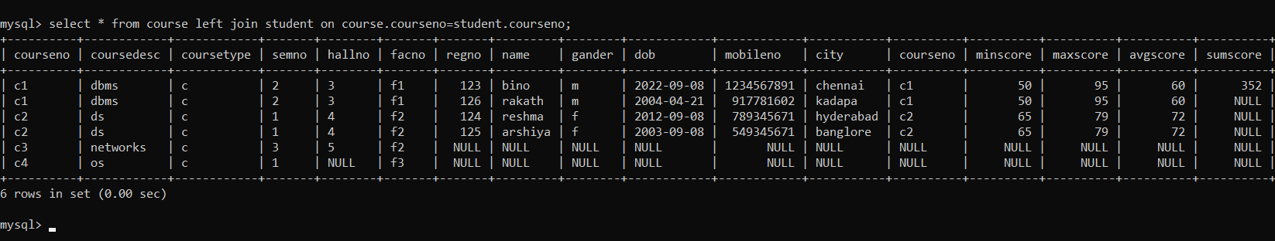

**Ex.No : 9**

**VIEW, INDEX, SEQUENCE**

1.Create a view with name ‘std_view’ using STUDENT table which holds the value of register number, name and DOB of student.

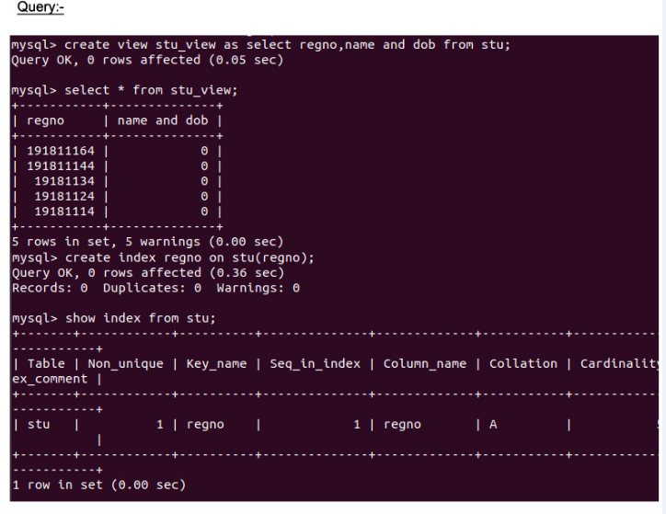

Ex:No: 10

**Simple programming exercise using(REPEAT, WHILE )**

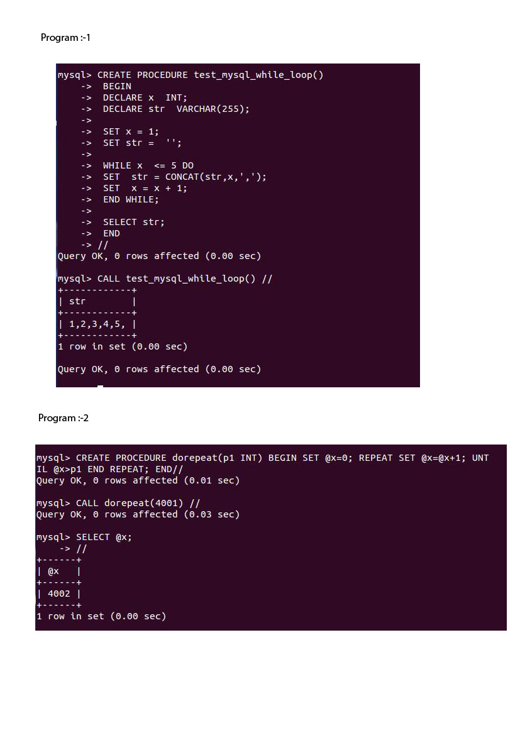

Ex.No : 11

**SELECT INTO, INSERT INTO SELECT STATEMENTS**

1.Create a new table course2 from course table

